| **Ex No: 1**  **Date: 13-08-24** | **Gradient descent implementation** |
| --- | --- |

**Objective:**

To build a logistic regression classifier to recognize cat’s vs non cat using Gradient descent implementation.

**Descriptions:**

Binary classification is the task of classifying elements of a given set into two groups. Logistic regression is an algorithm for binary classification. We have an input image x and the output y is a label to recognize the image. 1 means cat is on an image, 0 means that a non-cat object is in an image**.**

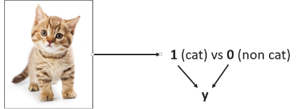

Logistic regression is a supervised learning algorithm that we can use when labels are either 0 or 1 and this is the so-called Binary Classification Problem. An input feature vector X may correspond to an image that we want to recognize as either a cat picture (1) or a non-cat picture (0). That is, we want an algorithm to output the prediction which is an estimate of y: Logistic Regression doesn't have a hidden layer. If you initialize the weights to zeros, the first example x fed in the logistic regression will output zero but the derivatives of the Logistic Regression depend on the input x (because there's no hidden layer) which is not zero. So at the second iteration, the weights values follow x's distribution and are different from each other if x is not a constant vector.

**Model:**

https://piehqfpkotypaenhpraenx.coursera-apps.org/notebooks/Week%202/Logistic%20Regression%20as%20a%20Neural%20Network/images/LogReg_kiank.pnghttps://piehqfpkotypaenhpraenx.coursera-apps.org/notebooks/Week%202/Logistic%20Regression%20as%20a%20Neural%20Network/images/LogReg_kiank.png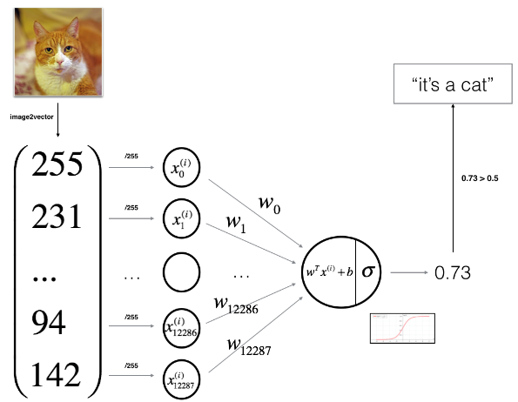

**Building the parts of algorithm**

The main steps for building a Neural Network are:

1. Define the model structure (such as number of input features)
2. Initialize the model's parameters
3. Loop:
   * Calculate current loss (forward propagation)
   * Calculate current gradient (backward propagation)
   * Update parameters (gradient descent)

**GitHubLink:** [**https://github.com/chandanab1/Deep_Learning**](https://github.com/chandanab1/Deep_Learning)